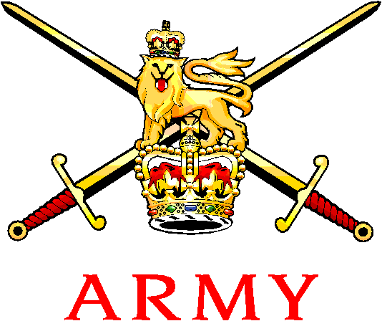 | Army Mountaineering Association  WINTER MEET LEADER  Captain Sean Mackey RDG  Email: sean.mackey570@mod.uk  Military: 95161 7505  Mobile: 07814729742 |  | 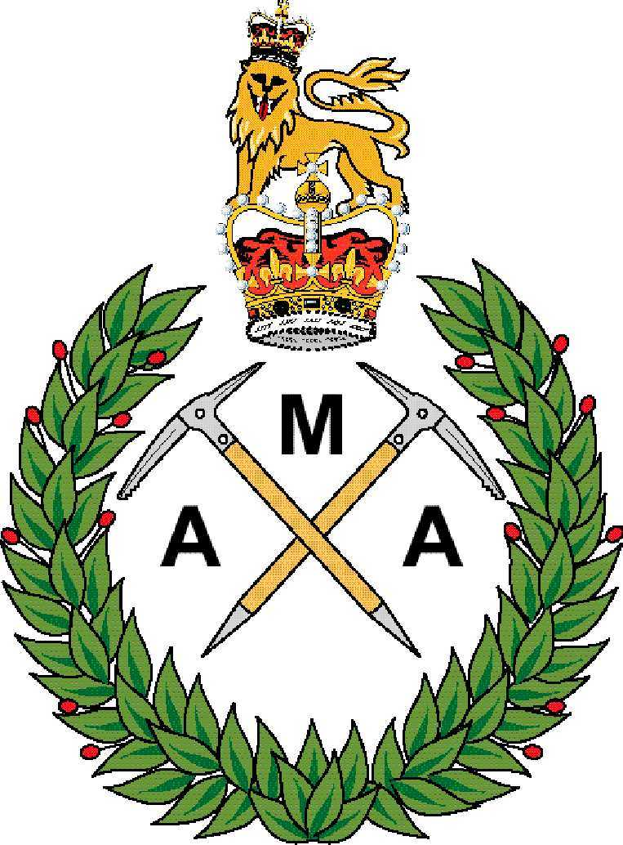
See Distribution |  | Reference: AMA/Winter_Meet_16  Date:

AMA WINTER MEET

Introduction. The Army Mountaineering Association Winter Meet will be held 20-26 February 2016 in Rothiemurcus, Scotland. The meet will give opportunities to members of the AMA to gain personal experience and instruction in winter walking, mountaineering and climbing.

- Aim. Primarily this meet is an opportunity to gain logbook experience towards JSAT qualifications and to potentially access refresher training under qualified tuition. There maybe an opportunity to gain JSAT qualifications depending on numbers and instructors.

3. Nominal Role. A full nominal role of personnel attending will be placed in ANNEX A when places are confirmed.

Ser | Appointment | Rank | Name | Remarks
(a) | (b) | (c) | (d) | (e)
1. | OIC | Capt | Mackey (Sean) | WML (T), WIT
2. | Technical Leader | Maj | Shipley (Tarquin) | WCI

- Program. A programme of events can be found in ANNEX B.

- Briefing. An initial brief will take place at 0800hrs Sun 21 February 2015 at the accommodation. All Members, without exception, are to attend the briefing.

- Transport. There is no group transport provided and individuals will need their own vehicles to move around. Units are encouraged to support this event with service vehicles as this is classed as an ON DUTY activity. Those travelling by rail should plan to arrive at Aviemore train station. The meet leader may be able to collect individuals if given prior notice. Car sharing is strongly encouraged. There are parking spaces available for personnel attending to utilise.

- Accommodation. The accommodation at Rothiemurcus can sleep 18 personnel in bunkhouse style rooms. There are excellent drying room facilities on site. Rooms are to be left clean and tidy before departure. All members are expected to arrive on the Saturday prior to the safety brief on the Sunday morning. Priority for the accommodation will go to members who are attending the whole week- individuals who can only attend weekends or mid week will need to contact the meets leader a minimum of two weeks prior to the meet.

- Feeding. All food will be an individuals responsibility. The accommodation is equipped with a kitchen and admin area with cooking pots, utensils etc. There are numerous pubs and cafes in the local vicinity.
- Equipment. Individuals must bring their own equipment and clothing, no kit is available from the organiser. The only exception is 20 x avalanche transceivers, snow shovels and probes which all meet members must carry. An example kit list can be found in ANNEX C.

- Duty Status. This weekend is given ON DUTY STATUS.

  - All individuals must be an up to date member of the Association in order to attend. The weekend is not an AT qualification course and therefore individuals must gain parent unit authority to attend and ensure details of the weekend are placed on Part 1 orders.
  - Duty status is provided under the ’Mountaineering as Sport’. The weekend is recognised as an official ASCB event, therefore travel and subsistence costs must be authorised by own unit budgets – ask your RAO.
  - Clearance via 51 Scottish Inf Bde will be sought prior to the meet taking place.

- Safety. A number of safety measures will be imposed for the duration of the meet. The overall personal safety of individuals rest with the leading qualified member of each activity group each day.

  - There will be a mandatory brief on each morning prior to activities taking place. The conduct of training is viewed very seriously by HQ Army and the AMA, so every measure necessary will be adopted to ensure activities are safe. The meet leader or technical leader has the authority to amend individual plans if insufficient experience is identified.
  - Regardless of personal experience unless individuals have a current JSAT qualification or equivalent they will be regarded as a novice.
  - In accordance with best practice, all personnel are required to wear the appropriate UIAA PPE for climbing. The wearing of helmets is mandatory for all climbers and mountaineers.
  - Safety briefs and risk assessments will be completed by each qualified group leader throughout the weekend. Dynamic risk assessments will need to be carried out throughout the days activities and are not limited to solely the group leader. Every member has a responsibility for their safety.
  - Personnel who wish to climb/walk in organised and qualified groups must comply with the following caveats:

    - Personnel are to book out and back in with the meet leader, leaving a list of names, training location and a contact mobile telephone number.

    - Personnel are to use their own equipment and transport.

    - JSP 419 ratios must be adhered to.

11. Local Information.There is pubs within walking distance of the accommodation. Any personnel who are hungover or intoxicated in the morning will be removed from that day’s activities. There are supermarkets and small shops in most of the towns and villages. Also there are many ‘outdoor’ shops in Aviemore including where extra equipment maybe rented for a small charge.

12. Payment. Cost will be primarily met by members with some support from AMA funds. A personal contribution of £80 will need to be sent via cheque or bank transfer to the AMA office (Mil - (9) 5581 7964 Civ - 01248 718364) once you have been confirmed a place. Any WML and WCI qualified personnel who are willing to lead groups will get a reduced price of £40. The personal contribution is non-refundable unless you have a letter from your chain of command stating that you are unable to attend due to service reasons.

13. Point of Contact. Contact Meet Leader for further information. Sean Mackey is the POC during the AMA weekend and all enquiries or problems over the period are to be directed to him.

14. Summary This week of winter mountaineering is a fantastic opportunity to network and enjoy the challenges of a great climbing, scrambling and walking area.

[Original Signed]

SW Mackey RDG
Captain
Meet Leader
For AMA Meets Co-ord

Annexes:

A. AMA WINTER MEET NOMINAL ROLE
B. AMA WINTER MEET PROGRAMME OF EVENTS
C. SUGGESTED KIT LIST

Distribution:

All AMA Members (via email and website)
All UATOs via G7 PD Branches;
HQ 1 (UK) Amd Div
HQ 3 (UK) Div
HQ Force Tps Comd
HQ Sp Comd
HQ LONDIST
HQ BFG
HQ Army Scotland

ANNEX A TO
AMA/Winter_Meet_16
DATED 29 June 2016
AMA WINTER MEET NOMINAL ROLE

SER | NUMBER | NAME | RANK | AMA No. | QUALS | REMARKS
1. | 30015482 | Mackey | Capt | 10643 | WMT, WIT | Meet Leader
2.
3.
4.
5.
6.
7.
8.
9.
10.
11.
12.
13.
14.
15.
16.
17.
18.

ANNEX B TO
AMA/Winter_Meet_16
DATED 29 June 15

AMA WINTER MEET PROGRAMME OF EVENTS

Date | Time | Activity | Activity WMF | Remarks
 |  | 1 x WML, 4 x WMTs, 2 x WCL & 4 x WMF | 1x WML & 6 x Students
Sat 20 Feb 16 | 1800 - 2300 | Members arrive. |  | OIC will book all members into the accommodation and allocate rooms.
Sun 21 Feb 16 | 0730 - 0800 | Breakfast
Sun 21 Feb 16 | 0800-0830 | Mandatory opening brief |  | Conducted in the accommodation.
Sun 21 Feb 16 | 0900 - 1800 | Skills Based Revision Day  Coire An’t Schnetcha ALL TO ATTEND |  | Groups are to book out.
Sun 21 Feb 16 | 1800 - 1845 | All attendees to book back in.
Sun 21 Feb 16 | 2030 | Brief and weather check for next day
Mon 22 Feb 16 | 0700 - 0730 | Breakfast
Mon 22 Feb 16 | 0800 – 1800 | Winter Climbing- Coire An’t Schnetcha Alladin’s Mirror (I) & Jakes Rake (I)  Winter Walking- Ben McDui via Fiacal Ridge |  | Technical Leader to discuss
Mon 22 Feb 16 | 2030 | Brief and weather check for next day
Tues 23 Feb 16 | 0700 - 0730 | Breakfast
Tues 23 Feb 16 | 0800 – 1800 | Winter Climbing-  Winter Walking- WMT- Navigation based day ivo Glen Feshie  WML Group- Journey Day ivo Bynack Moore |  | Technical Leader to discuss
Tues 23 Feb 16 | 2030 | Brief and weather check for next day
Weds 24 Feb 16 | 0700 - 0730 | Breakfast
Weds 24 Feb 16 | 0800 – 1800 | Winter Climbing-  Winter Walking- |  | Technical Leader to discuss
Weds 24 Feb 16 | 2030 | Brief and weather check for next day
Thurs 25 Feb 16 | 0700 - 0730 | Breakfast
Thurs 25 Feb 16 | 0800 – 1800 | Winter Climbing-  Winter Walking- |  | Technical Leader to discuss
Thurs 25 Feb 16 | 2030 | Brief and weather check for next day
Fri 26 Feb 16 | 0700 - 0730 | Breakfast
Fri 26 Feb 16 | 0800 – 1000 | Clean Accomodation
Fri 26 Feb 16 | 1015 | Leave

ANNEX C TO
AMA/Winter_Meet_16
DATED 29 June 2015
SUGGESTED KIT LIST

Waterproof Jacket Harness (Winter Climbing Only)
Waterproof Trousers/Salopettes Rope (Winter Climbing Only)
Fleece/softshell tops Winter Climbing Rack (Winter Climbing Only)
Softshell trousers Sleeping bag (If planning to use a bothy)
Ronhill type baselayer bottoms Bivi bag (If planning to use a bothy)
Baselayers Tops Roll Mat (If planning to use a bothy)
Warm Down or Softie Type Jacket
Socks
Underwear Supplied by AMA:
Wash kit and towel Avalanche Transceiver
Probe
Four Season Boots Shovel
Ice Axe(s)
Crampons
Helmet
Drybags
Daysack (35L+)
Hats and Gloves (minimum of two pairs)
Walking Poles (Optional)
Water bottles
Lunchbox
Goggles

Sunglasses
Suncream (Highly unlikely to be used!)
Camera

Personal clothing for the evenings
Laptop

